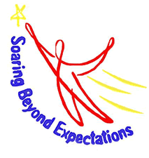
Primary Program
April & May 2018
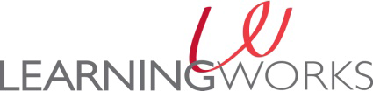
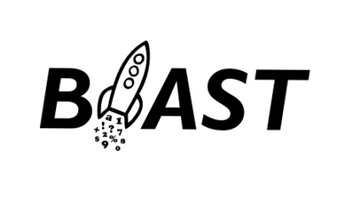

21St Century Grant

Monday Tuesday Wednesday Thursday Friday
April 2  Mt Washington Weather Observatory Virtual Trip | April 3  STEM  Engineering Weather Instruments | April 4  Early Release  No BLAST | April 5  Teen Trendsetters or Math Games | April 6  NO BLAST
UNE Dental Students Visit | April 10  STEM  Engineering Weather Instruments | Rescheduled Visit April 11  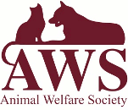 | April 12  Teen Trendsetters or Math Games | April 13  NO BLAST
April 16  Vacation | April 17  Vacation | April 18  Vacation | April 19  Vacation | April 20  NO BLAST
April 23  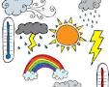 | April 24  Field Trip to UNE Pool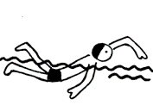 | April 25  STEM  Engineering Weather Instruments  Clubs | April 26  Teen Trendsetters or Math Games | April 27  NO BLAST
April 30  Weather Experiments  Clubs | May 1  STEM  Engineering Weather Instruments | May 2  Early Release  No BLAST | May 3  Teen Trendsetters or Math Games | May 4  NO BLAST
May 7  Artist in Residence Circus Smirkus Student Workshops All Week! | May 8 | May 9  Circus Practice | May 10  Student Performance with Circus Smirkus  BPS Café 3:45  Please join us! | May 11  NO BLAST
We invite you to visit some websites at home that will help support the learning we have designed for BLAST in April and May.
https://www.mountwashington.org https://www.engineergirl.org
http://www.smirkus.org http://www.screenfree.org

Contact Us: Bus Department (207)282-0909
Deb Jaime, Site Coordinator (207)251-2569 or djaime@biddefordschools.me
Marci Dionne, Director (207)251-5571 or mdionne@biddefordschools.me
Please check out the LearningWorks BLAST page on Facebook for program updates: at facebook.com/BLAST-LearningWorks-Biddeford

