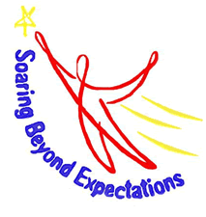
Intermediate Program
April & May 2018
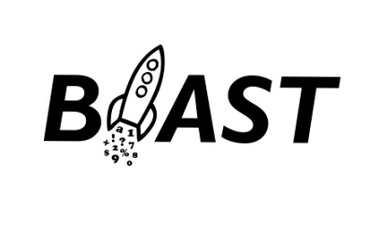
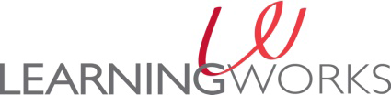

21St Century Grant

Monday Tuesday Wednesday Thursday Friday
Please mark your calendar for the UNE Math Night on April 25.
BIS BLAST students will perform a circus event for parents on May 17.

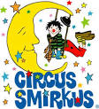
We invite you to visit some websites at home that will help support the learning we have designed for BLAST in April and May.
https://www.mountwashington.org https://www.engineergirl.org https://www.juniorachievement.org/web/ja-maine/
http://www.smirkus.org http://www.screenfree.org
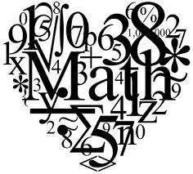
April 2  Mt Washington Weather Observatory Virtual Trip | April 3  Clubs | April 4  Early Release  No BLAST | April 5  Junior Achievement | April 6  NO BLAST
UNE Dental Students Visit | April 10  Clubs | April 11  UNE Math Mentors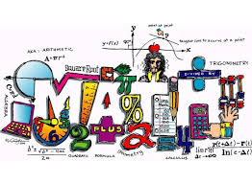 | April 12  Junior Achievement | April 13  NO BLAST
April 16  Vacation | April 17  Vacation | April 18  Vacation | April 19  Vacation | April 20  NO BLAST
April 23  Field Trip to UNE Pool | April 24  Junior Achievement | April 25  UNE Math Mentors Host the Family Math Night  Please join us in the BIS Café at 3:45 | April 26  New Clubs! | April 27  NO BLAST
April 30  Junior Achievement | May 1  Junior Achievement | May 2  Early Release  No BLAST | May 3  New Clubs! | May 4  NO BLAST

